Framing Equality, 23 October at 7 pm

Atrium of the Centre of the Slovenian Academy of Sciences and Arts

ZRC SAZU

**INTERCULTURAL EVENT & PHOTOGRAPHY EXHIBITION**

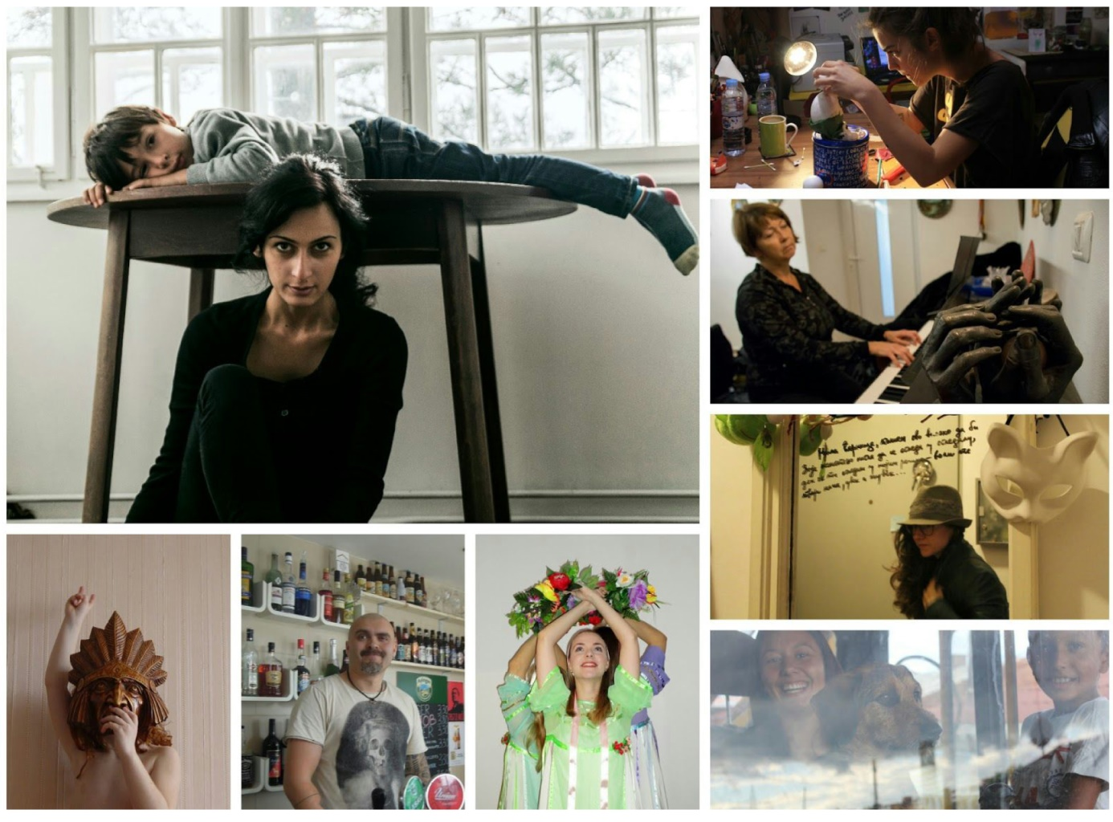

**Framing Equality**

You are cordially invited to the opening of the photography exhibition on Friday, 23 October at 7 pm in the Atrium of the Center of the Slovenian Academy of Sciences and Arts. The exhibition will feature photostories by the participants of the Framing Equality workshops.

- *The authors & the series:*

- *Nino Bektashashvili* - The Story of Her

- *Egzona Berisha* – My Family

- *Iryna Furst* - Confrontations: Portraits of Ukrainians in Slovenia

- *Elena Kyrachkova* - Življenje igrač - The Life of Toys

- *Yuliya Molina *- Ljubo doma, kdor ga ima - Home Sweet Home

- *Jasna Rajnar Petrović *- Saaaaam' GOR! - Oooooonly UP!

- *Iryna Stanković* - Slovenija in Ukrajina, sestri slovanskega etnološkega

The photographs were the product of photography and video workshops aimed at strengthening the role and power of migrant and Roma women. The opening of the photography exhibition will be followed by a discussion with the

authors of photograph and mentor Manca Juvan and Romana Zajec. The discussion will be moderated by mentor Dr. Mirjam Milharčič Hladnik.

The evening programme will include music and dance:

- dance group RITMI PLANETA

- vocal group RUSKI TALISMAN

- break dance group of the GOR association

- music group ETNO POT with Darja Darja Resnik Debevc

- DJ ĐIGA and DJ PRIMZ*I

- DJ duo SARAIEVA

The event is organised by *APIS* Institute and the *Migration Institute at the Research Center of the Slovenian Academy of Sciences and Arts*.

The “Framing Equality” project is co-financed by *The Ministry of Work, Family, Social Affairs, and Equal Opportunities*.

**Welcome!**

